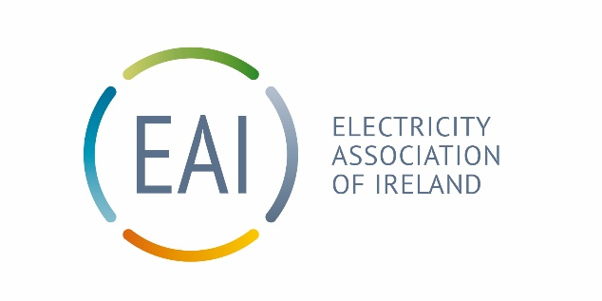
Electrification remains the best opportunity to lower total energy bills for households
Following the publication by Eurostat of electricity prices both for household and non-household consumers in the European Union (EU) for the last 6 months of 2025 it is evident that the price of energy in the EU depends on a range of different supply and demand conditions. This includes the national energy mix, import diversification, network costs and the levels of regulatory costs, excise and taxation.
While electricity prices have increased in most EU countries for 2025 compared to 2024, Eurostat stated that for medium-sized household consumers with an annual consumption between 2 500 Kilowatt-hours (kWh) and 5 000 kWh), electricity prices in the second half of 2025 were highest in Ireland (€0.4042 per kWh). This was about 1.5c above the next highest country Germany.
However, when ‘purchasing power’ is considered, Irish household electricity prices drop to 5th in the EU.
Purchasing power takes account of differences in the cost of living between countries. That is how much it would cost to buy the exact same amount of goods, rather than simply comparing prices in euro. As a result, one euro does not have the same buying power across all Eurozone countries because the cost of goods and services varies significantly from country to country.
Retail residential electricity prices usually consist of four main components: energy costs; network expenses; government surcharges/taxes; and value added tax (VAT). The following sets out why these costs are higher in Ireland
Energy Costs in Ireland (50% of the bill)
Ireland uses gas to generate 50% of its energy and imports 70% of its gas. The wholesale price of gas in Ireland is set by international markets plus the cost of transport to Ireland via the interconnectors. This dependency has increased the cost of electricity, with current gas prices over 3 times the price before the Russian invasion of Ukraine.
Network costs (20-30% of the bill)
These costs are required to keep the lights on with emergency generation, build and repair transmission wires and generation plants as well as connecting thousands of new homes. These costs are also used to keep the system balanced. As the share of variable renewable generation increases so too do the costs to balance. Ireland has one of the most dispersed networks in Europe with one of the highest lengths of grid/person to maintain.
Government Surcharges, Taxes and VAT
The proportion of taxes and levies in the overall electricity retail price for Irish household consumers was one of the lowest in the EU. While the Public Service obligation (PSO) currently about €0.34/wk/customer.) supports a growing renewable development.
Supplier costs
Suppliers buy energy in advance, and use hedging to reduce volatility and protect customers from the worst impacts. While hedging delays price increases it cannot avoid them. Other Supplier costs have increased due to the roll out of SMART Meters, increased obligations for energy efficiency and increased regulatory requirements with Bad Debt carried by the sector estimated to be €150 million. Nearly 90% of the bill is collected by suppliers and passed on to system operators, public authorities, and generators.
Competition in the market
While the cost of Electricity in Ireland is high, the electricity market remains very competitive prices vary with fixed and variable tariffs and cost savings for the customer to be had. The regulator for the sector has looked at the margins that electricity suppliers earn on two occasions over the last 8 years and on both occasions indicated that they were in line with their expectations.
Vulnerable Customers
When energy prices are high the priority must be vulnerable customers. As we move away from fossil fuels and toward electrification – supports should be focused on the electricity Bill. The Department of Social Protection has a role to play here with a credit option of electricity Bills, and maximum public funding for the warmer homes scheme.
The way forward
Electrification remains the best opportunity to lower total energy bills for households due to significant efficiency gains over car engines and oil boilers, while taking advantage of cheap nighttime electricity to power your home The most effective long-term solution to high energy prices is the rapid deployment of domestic renewable generation. alongside investment in networks, storage and system flexibility, which will reduce reliance on gas-fired generation and enhance Ireland’s energy security,

Source

SEAI calculate the effective unit price of energy (the revenue collected for energy delivered, divided by the total quantity of energy delivered)
